FUN Run/Walk! orWalk!

R

FUN Run/Walk!

**\* Day of registration add additional $5 per registration**

|  |  |
| --- | --- |
| **Adults**  **$25** | **Kids 12 & Under**  **$10** |
| **___** 2mi Run | **___** 2mi Run |
| **___** 5K Run | **___** 5K Run |
| **___** 2mi Walk | **___** 2mi Walk |
| **___** 5k Walk | **___** 5K Walk |

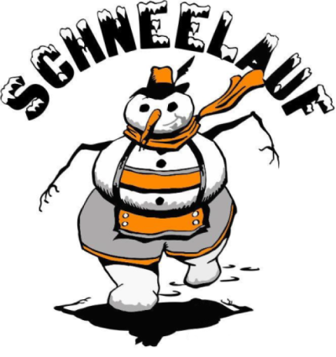

**Saturday, January 28, 2023 – 10 A.M.**

**Start & Finish at Quit Qui Oc Golf Club500 Quit Qui Oc Lane**

**.**

**\*Parking Available\***

**\*Day of registration add additional $5 per registration**

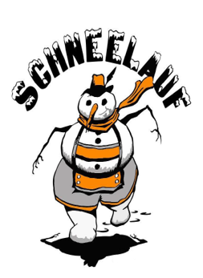

|  |  |
| --- | --- |
| **Adults**  **$25** | **Kids 12 & Under**  **$10** |
| **___** 2mi Run | ___ 2mi Run |
| **___** 5K Run | ___ 5K Run |
| **___** 2mi Walk | ___ 2mi Walk |
| **___** 5K Walk | ___ 5K Walk |

**Saturday, January 28, 2023 – 10 A.M.**

**Start & Finish at Quit Qui Oc Golf Club500 Quit Qui Oc Lane**

**\*Parking Available\***

Please return form to the Elkhart Lake Chamber of Commerce or email form to [chamber@elkhartlake.com](mailto:chamber@elkhartlake.com)

Paid participants will receive a Schnee Days

Winter hat, Gloves, Button & Finisher Medal!

**WAIVER OF LIABILITY**

In consideration of the acceptance of my entry in the SchneeLauf Run/Walk on January 28, 2023, I release the Elkhart Lake Chamber of Commerce, Village of Elkhart Lake, Quit Qui OC Golf Club, and any other entities and individuals who are in any way connected with the event (including additional sponsors and volunteers assisting with the event) from any liability or claims for any injury or illness which I sustain during my participation in this event or which is in any other way related to this event. I understand that this release applies to myself and my personal representatives and heirs, and acknowledge that this release is being relied upon by the persons permitting me to participate. Further, I hereby grant full permission to any and all of the foregoing to use any photographs, videotapes, motion pictures, recordings or any other record of this event for any legitimate purpose.

**Signature**___________________________________

*Parent/guardian signature if entrant is under 18*

**EMERGENCY CONTACT**

Name_______________________________________

Phone #_______________________________________

Thank you to our **SPONSORS**

who help make this event possible!

First Name: __________________________________

Last Name: __________________________________

Address: ____________________________________

City/State: ___________________________________

Email: _______________________________________

**WAIVER OF LIABILITY**

In consideration of the acceptance of my entry in the SchneeLauf Run/Walk on January 28, 2023, I release the Elkhart Lake Chamber of Commerce, Village of Elkhart Lake, Quit Qui OC Golf Club, and any other entities and individuals who are in any way connected with the event (including additional sponsors and volunteers assisting with the event) from any liability or claims for any injury or illness which I sustain during my participation in this event or which is in any other way related to this event. I understand that this release applies to myself and my personal representatives and heirs, and acknowledge that this release is being relied upon by the persons permitting me to participate. Further, I hereby grant full permission to any and all of the foregoing to use any photographs, videotapes, motion pictures, recordings or any other record of this event for any legitimate purpose.

**Signature**____________________________________

*Parent/guardian signature if entrant is under 18*

**EMERGENCY CONTACT**

Name________________________________________

Phone #________________________________________

Thank you to our **SPONSORS**

who help make this event possible!

Please return form to the Elkhart Lake Chamber of Commerce or email form to [chamber@elkhartlake.com](mailto:chamber@elkhartlake.com)

Paid participants will receive a Schnee Days

Winter hat, Gloves, Button & Finisher Medal!

First Name: __________________________________

Last Name: ___________________________________

Address: _____________________________________

City/State: ___________________________________

Email: _______________________________________